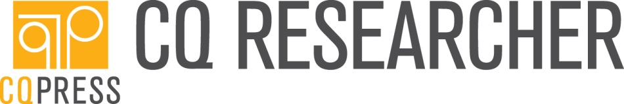

Dear [name],
Our library is currently conducting a trial of CQ Researcher. This award-winning online publication delivers 44 single-topic reports each year on newsworthy social and political issues. Each 13,000 word report is an original work, researched and written by seasoned journalists and professionally fact-checked. CQ Researcher provides students and faculty with the perfect first step in research and discovery. I’d appreciate if you’d take a look at the product and let me know what you think. We have access through DATE at this link: http://library.cqpress.com/cqresearcher/
Incorporate CQ Researcher into your course
“The shining example of what a truly brilliant research resource can be.” – Library Journal
CQ Researcher is an excellent pedagogical tool in teaching students how to research and write. Covering key topics in current events, public policy, law and civil liberties, international affairs, economics, health, education, the environment, and technology, trust CQ Researcher to be an authoritative, quality source of timely content. Each report:
- Features a structured and easy-to-use format
- Poses and addresses three major questions surrounding the issue
- Includes a “Pro/Con” debate by respected experts
- Guides students to logical sources for the next steps in their research
Check out a sample course assignment here.
Again, I’d appreciate your thoughts on this product as we consider adding it to our collection.
Thank you,
LIBRARIAN NAME AND INFO

